Final Design Doc of Movie Theatre

The initial design is not good enough, so I had to do some optimize for system design.
The classes design:
There are three packages (or module) in this system. Model, perspective, and main.

- Model
Model package include some entity class, like as Customer, Manager, Movie, Order etc. Every class have some Attributes and methods. In Movie case, there are six Attributes and two method (except GETTER/SETTER). the attributes are title, price, description, release time, level of movie, also have a list of time when this movie will deploy. Methods are getter and setter with all attributes, and a “toString”/ “readFromString" method.

A abstract class was created in this package, because all the model have some same method. Then they can implement in the super class. Why the super class is abstract? Models have to read from file to get a object. But every model has different format, so we define a method to read/save. Every model implement itself.

This is same of the doc that had provided in design time. But then I found some fields only have fixed number of values, like the type of ticket, the rate of a movie.

So these values can be implemented be a ENUM class.Enum class is safe , efficient and clearly. I will show this in the UML Class Diagram.

2.Perspective:

Perspective had a little of modify. I create an abstract class to be their parent. Some common field like a frame, a method like in it that frame is written in this file.

- Main

Global manager of this system. Run the GUI and exit.
- run: start the GUI
- exit: exit. Include normal exit and exit when get some wrong.

The Class hierarchies and relationships:(UML Class Diagram)

- Model
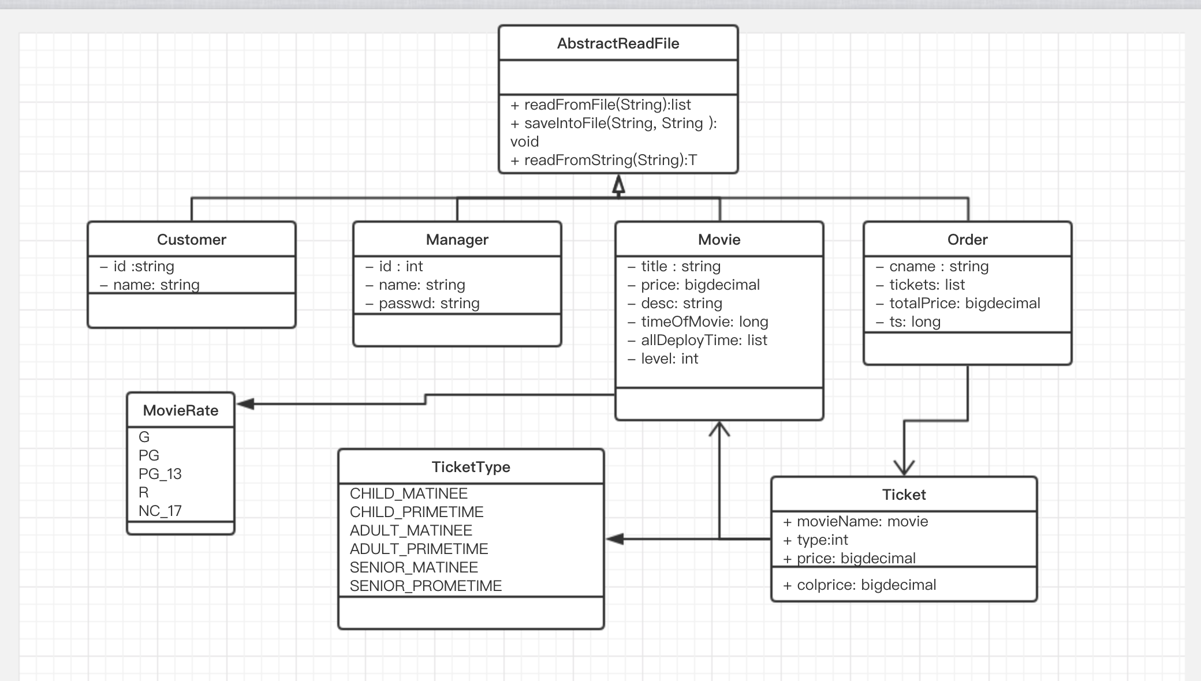

- Perspective
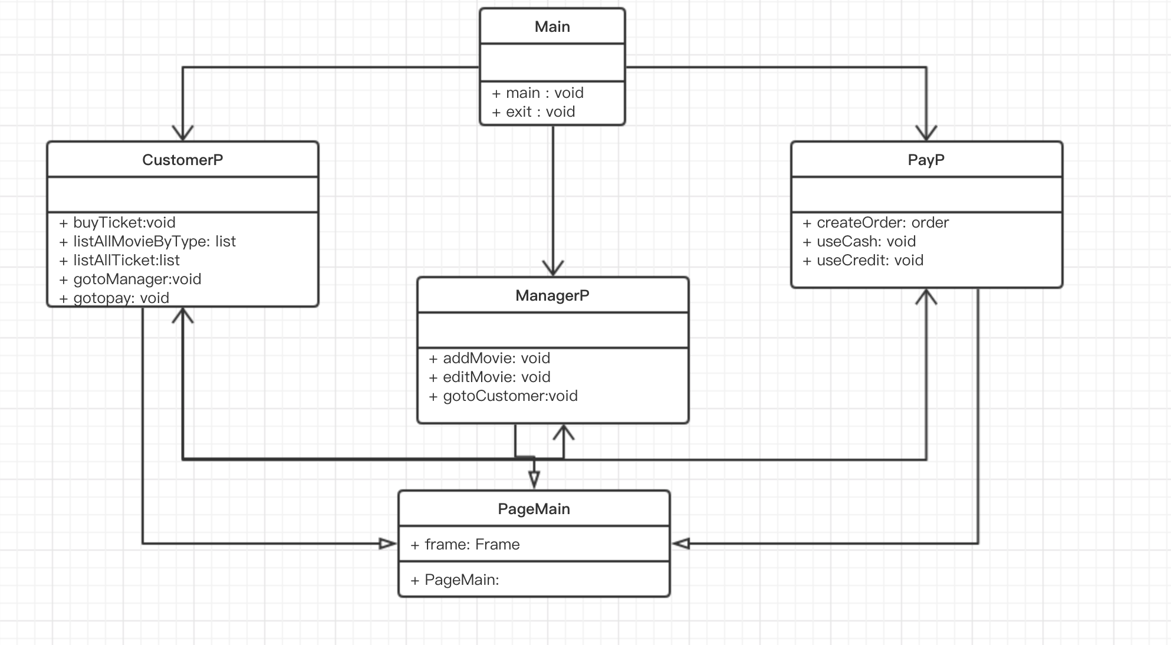

2.The UML Activity Diagram:

UML Active diagram haven’t modified.

The Other data structures or files:
There are also some data file:
- customer.txt
- Manager.txt
- Movie.txt
- Order.txt

Screen shots:
- customer-home-page:
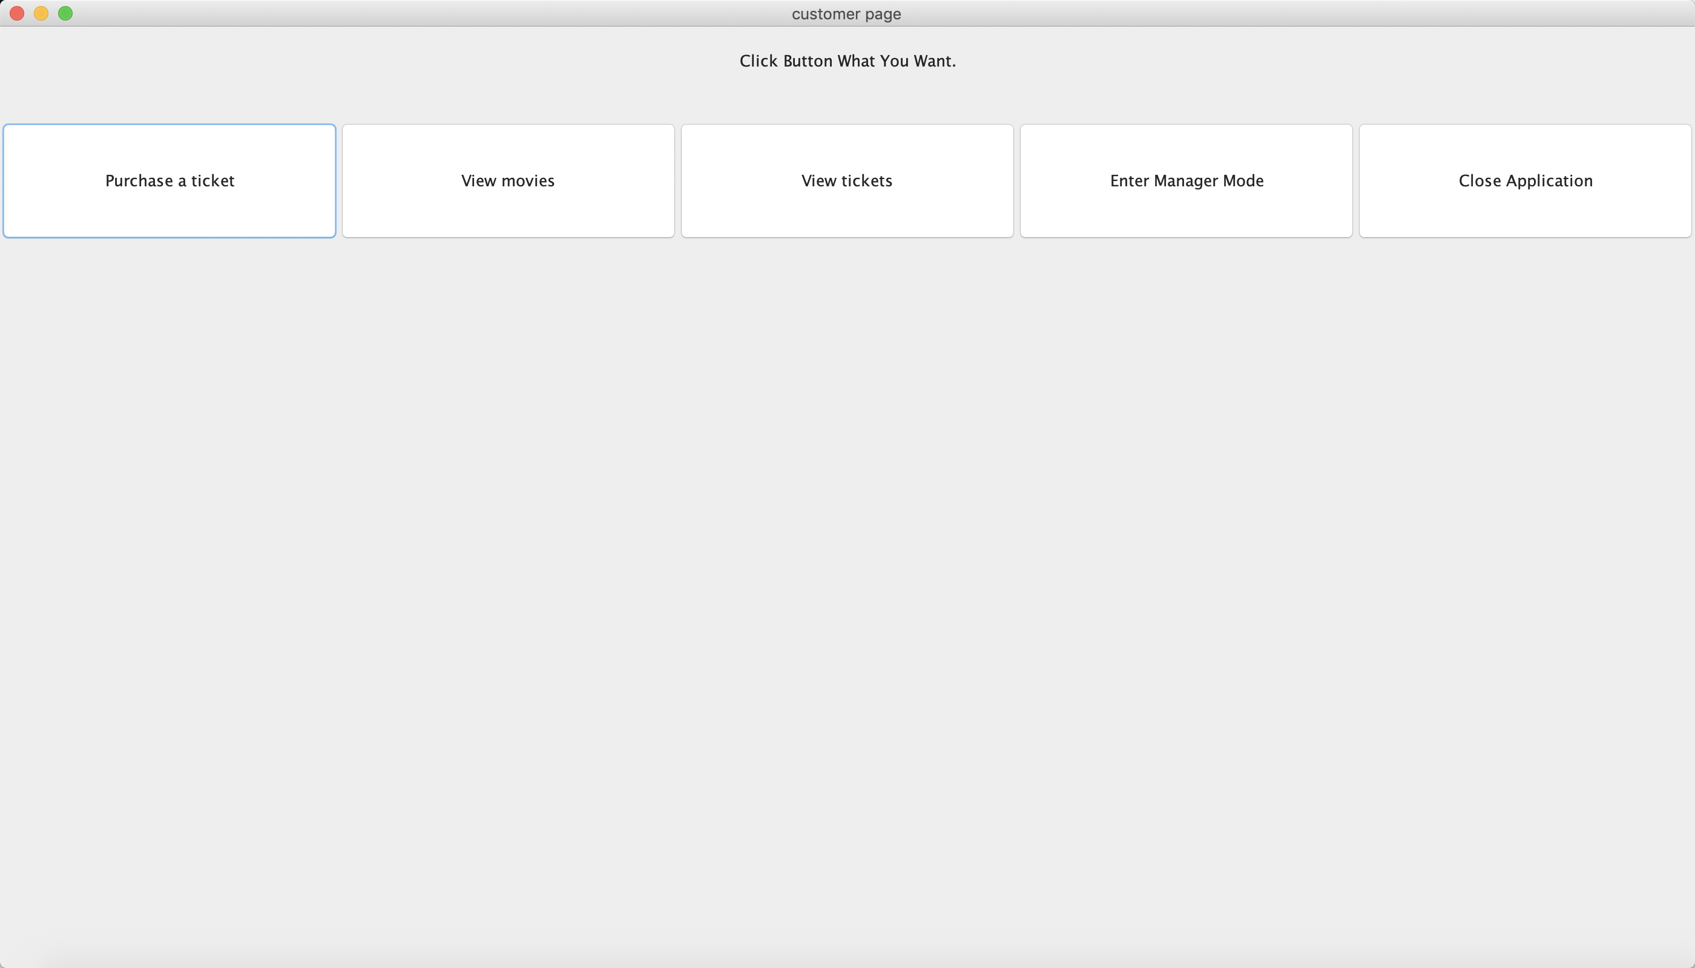
- buy a ticket page
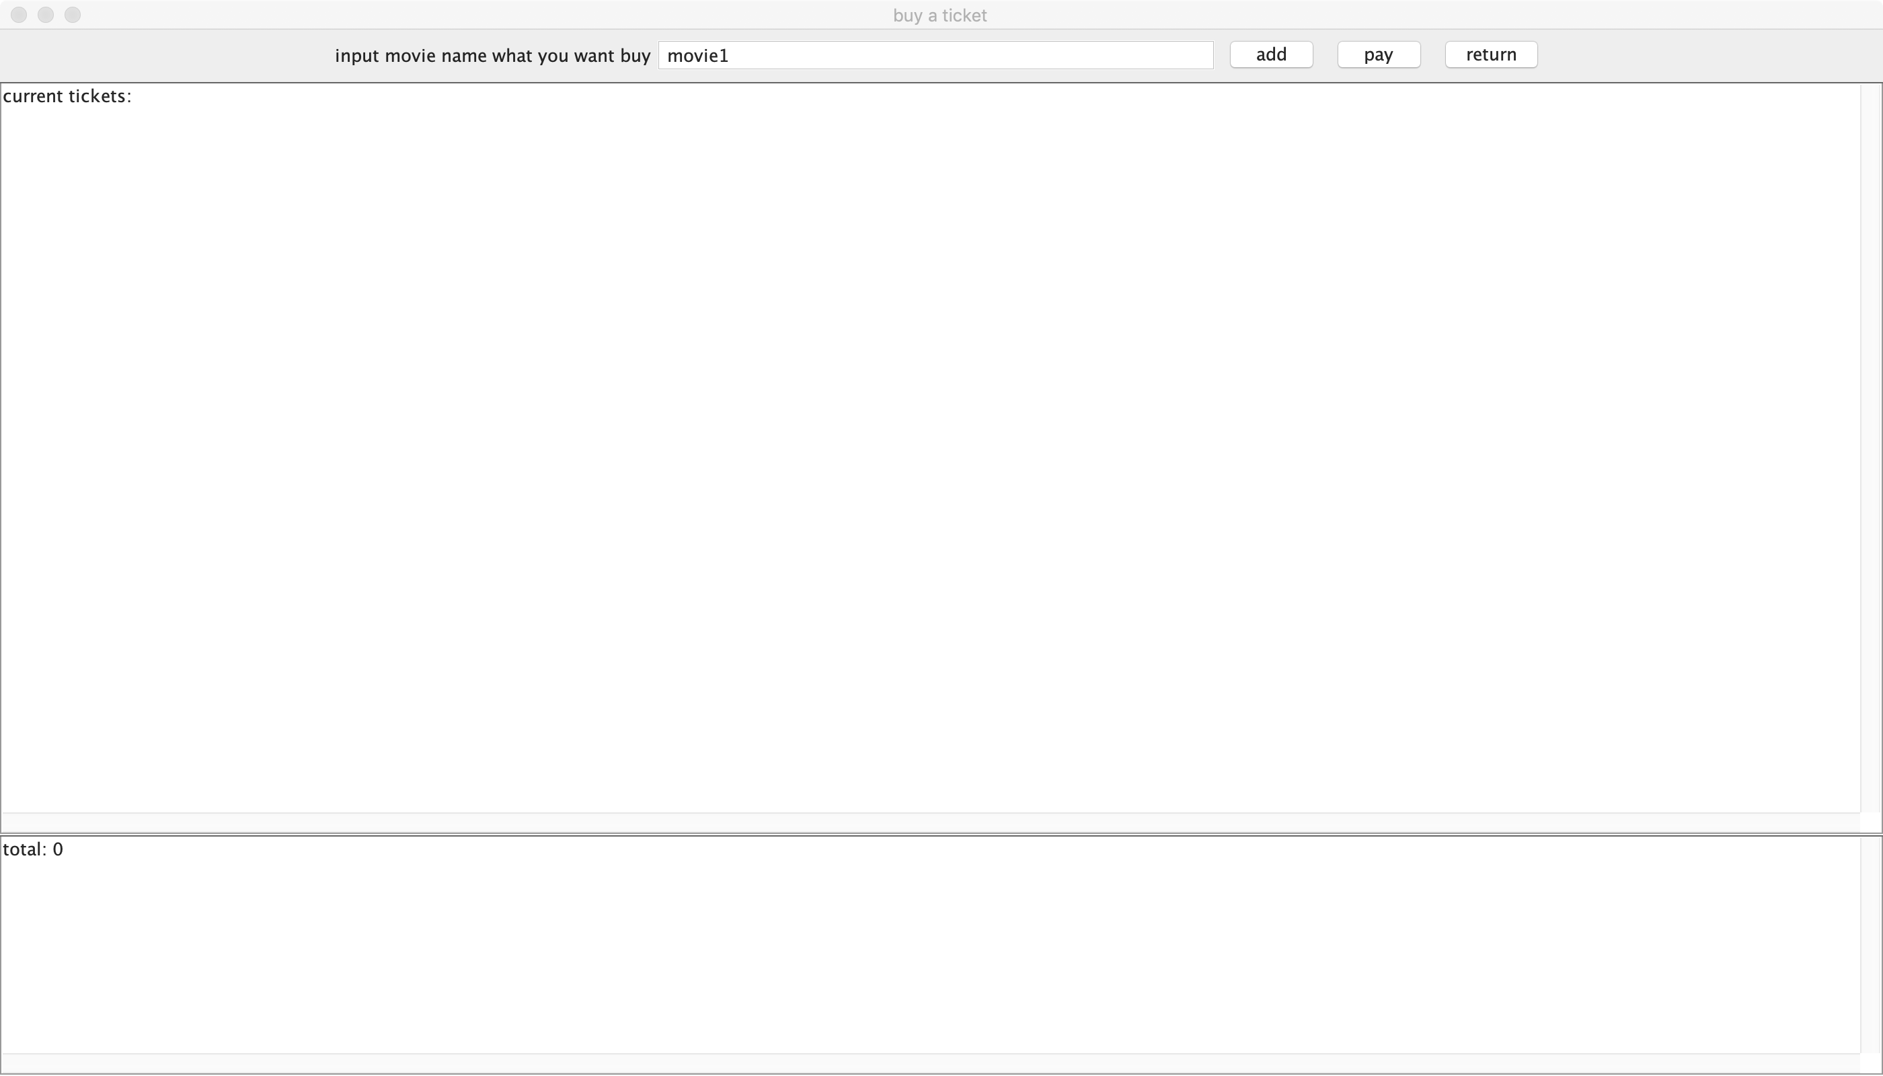
- pay buy credit
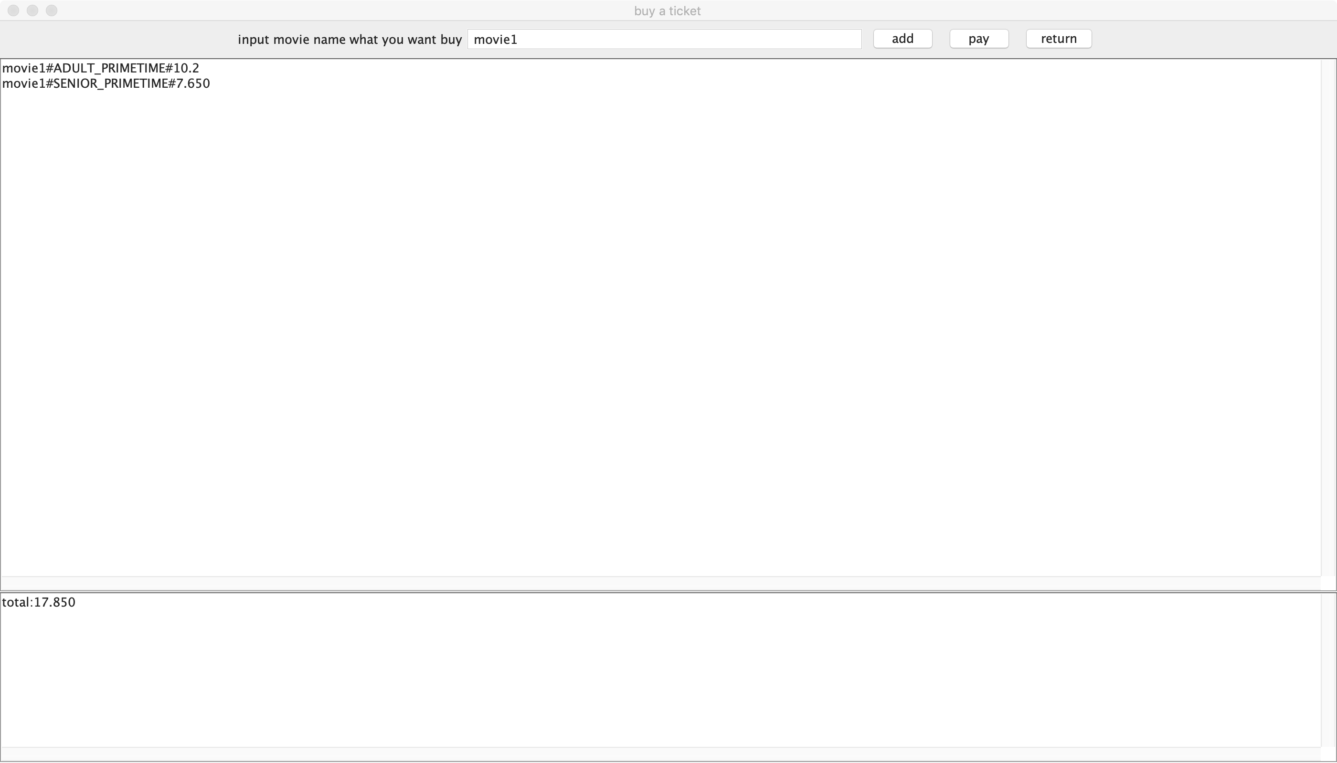
- after pay, show the order.
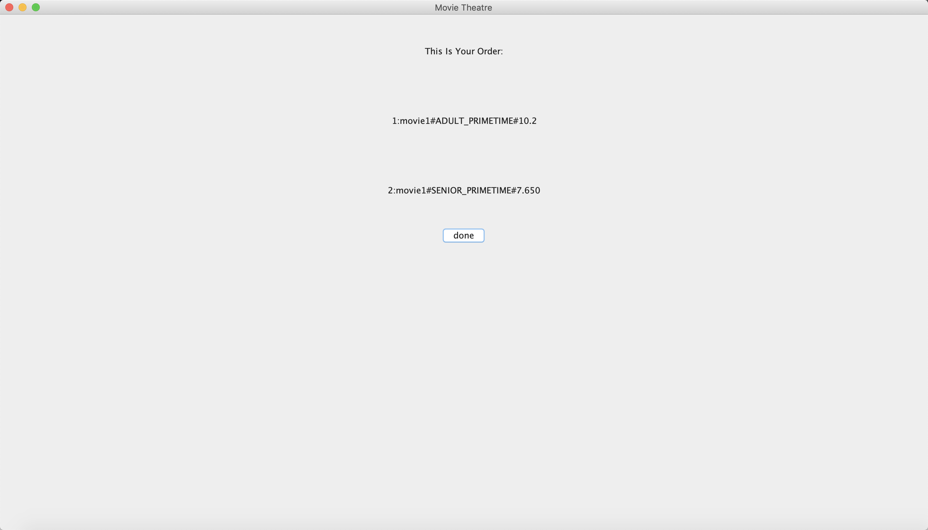
- list all movies
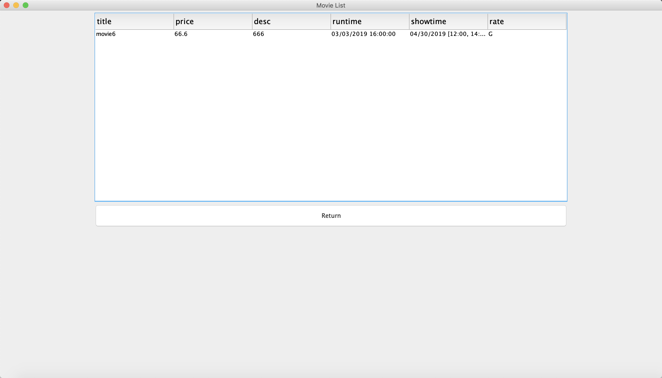
- list his/her tickets
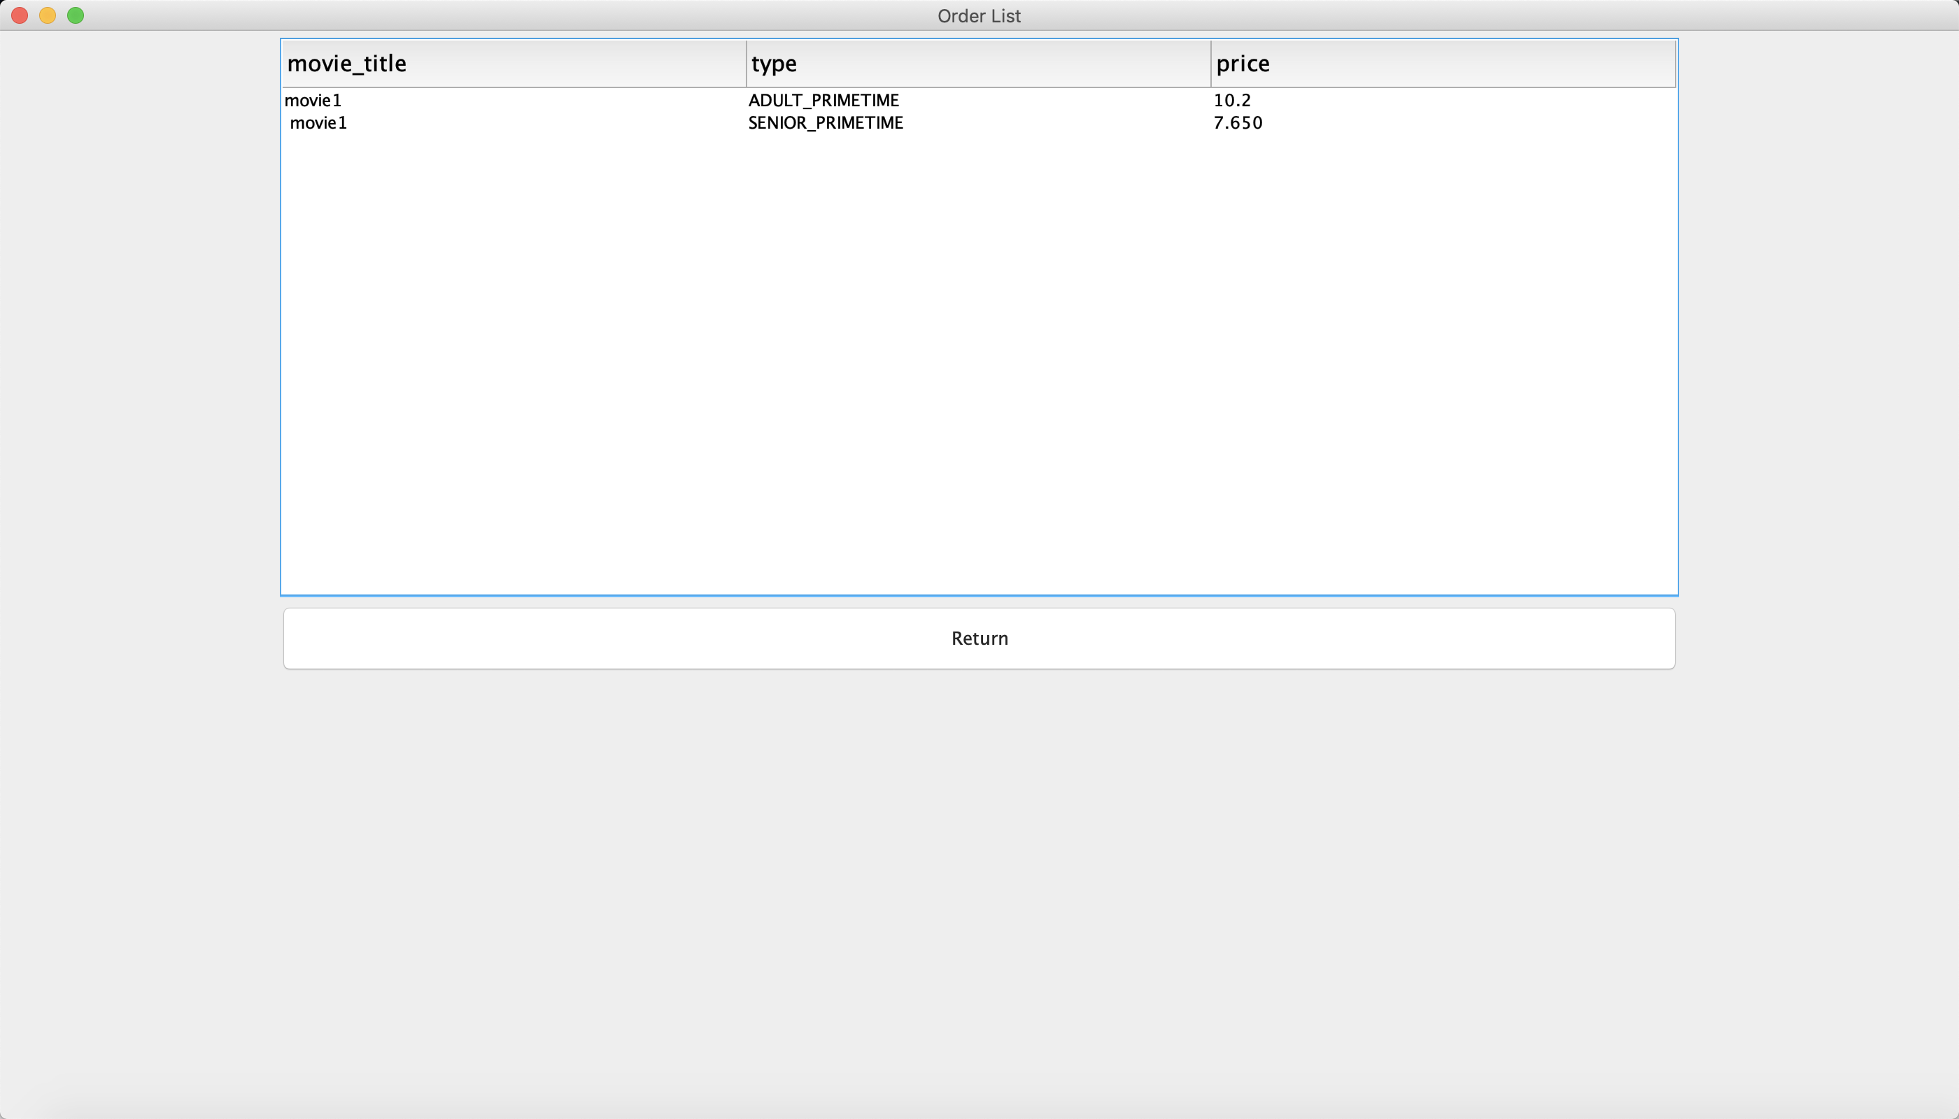
- entry manager perspective
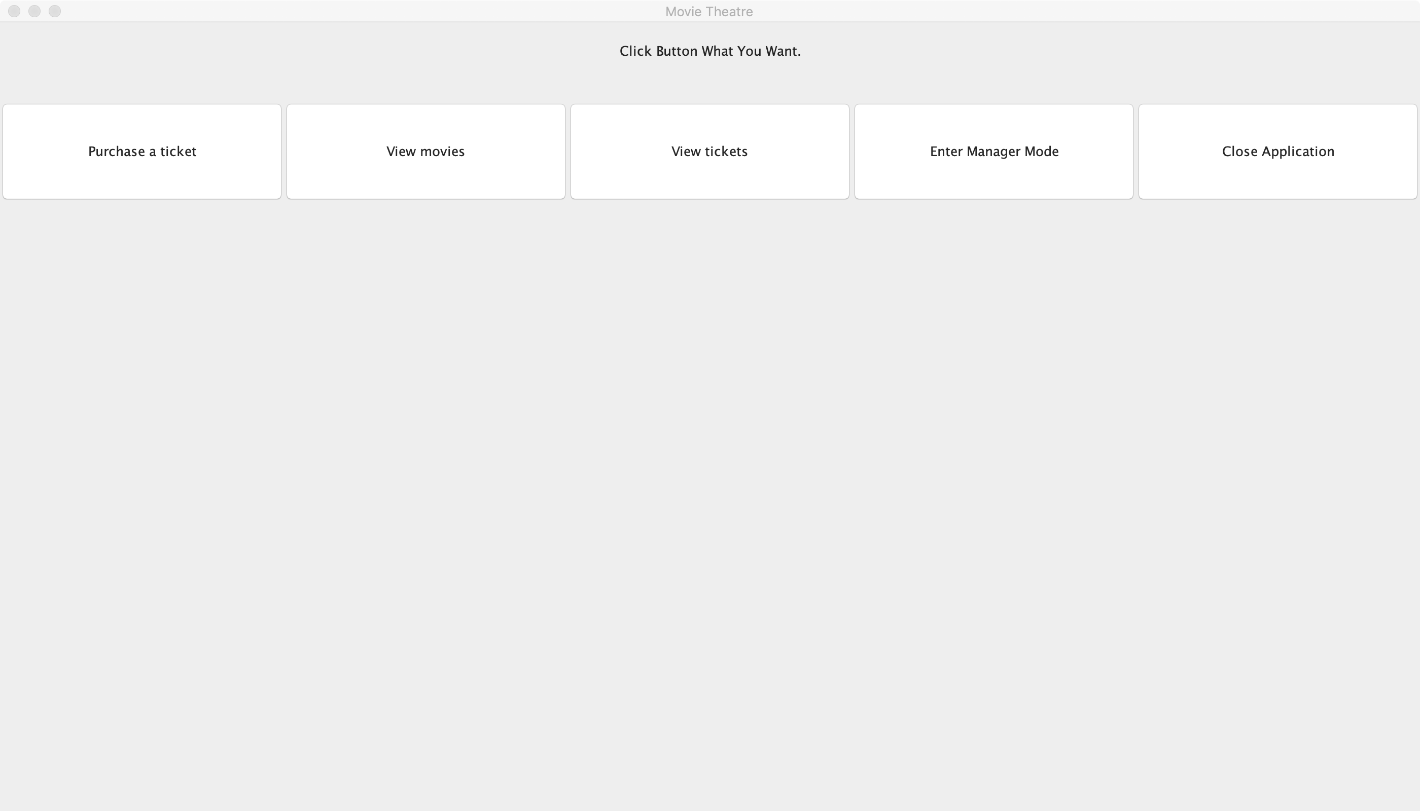
- add a movie
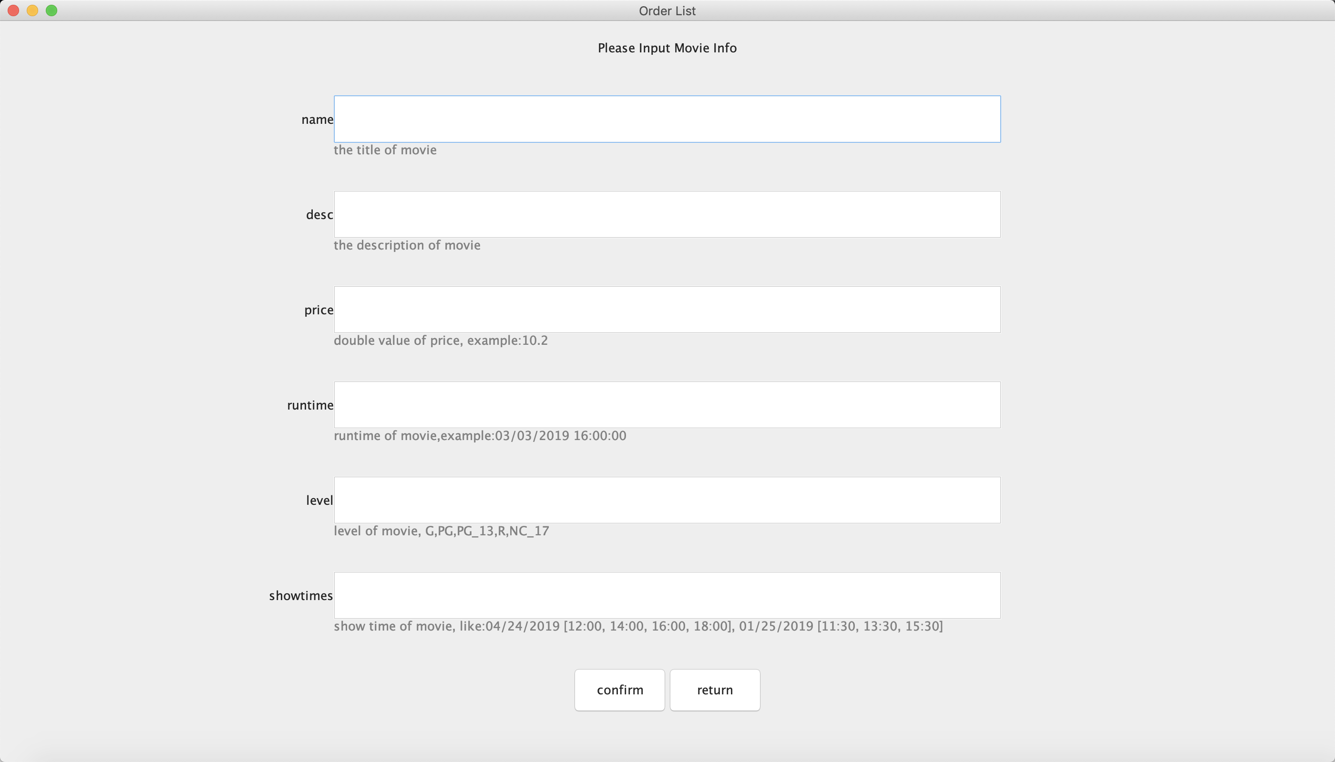
- edit a movie
